SET 5
Q1. Data Structures & Algorithms (5 Marks)
Using AI assistance, write a Python script to implement Merge Sort.
Your script should:
- Take a list of unsorted integers as input
- Use Merge Sort to sort the list
- Print each merge step (showing how subarrays are combined)
CODE:
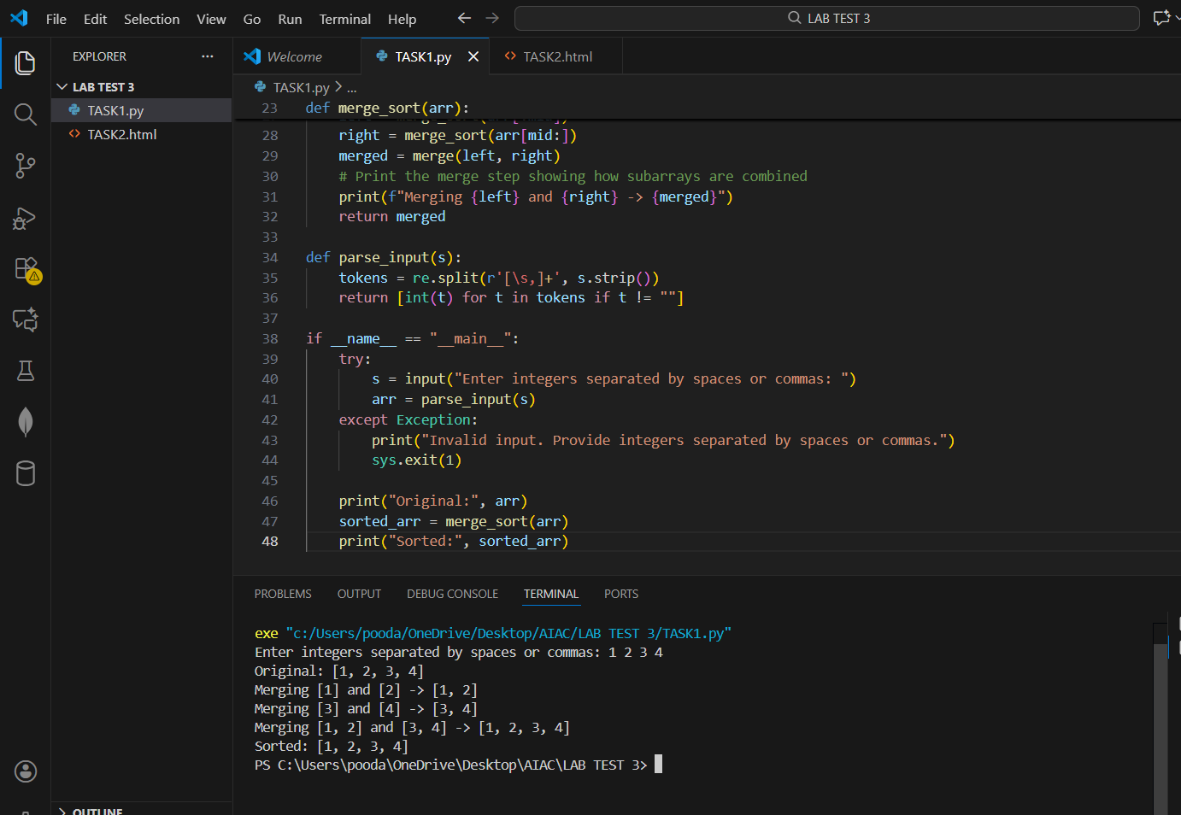
Q2. (Web Frontend – 5 Marks)
With AI assistance, generate a your personal Portfolio Website including

CODE :

